<https://docs.github.com/es/get-started/writing-on-github/getting-started-with-writing-and-formatting-on-github/basic-writing-and-formatting-syntax>

**Enmanuel Ordoñez** enmanuel.a.o.l@gmail.com  
**Fernando Poblete** pobletefernando@yahoo.com

**Juan Gonzalez** juan.m.gonzalez.j@gmail.com  
**Jorge Riquelme** Jorge.riquelme.z@gmail.com

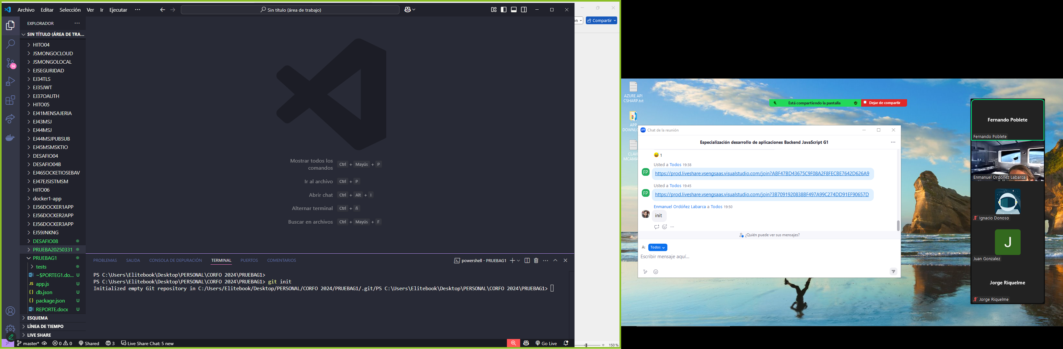

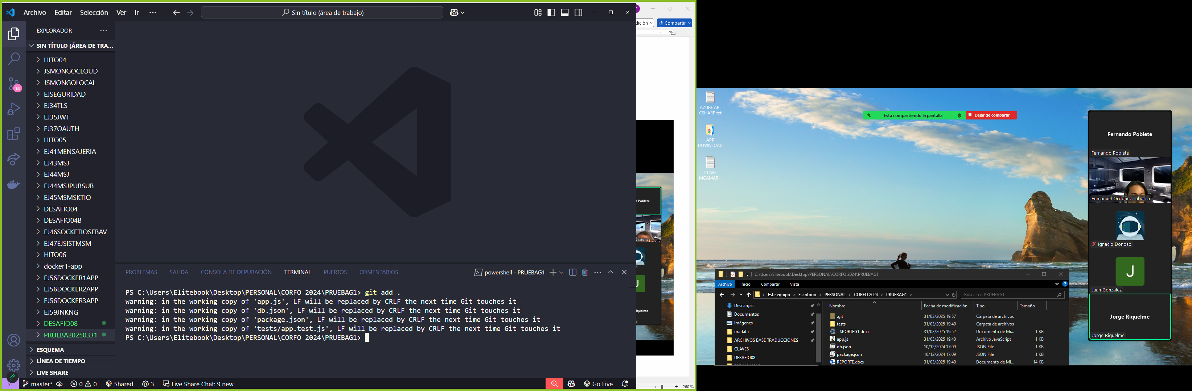

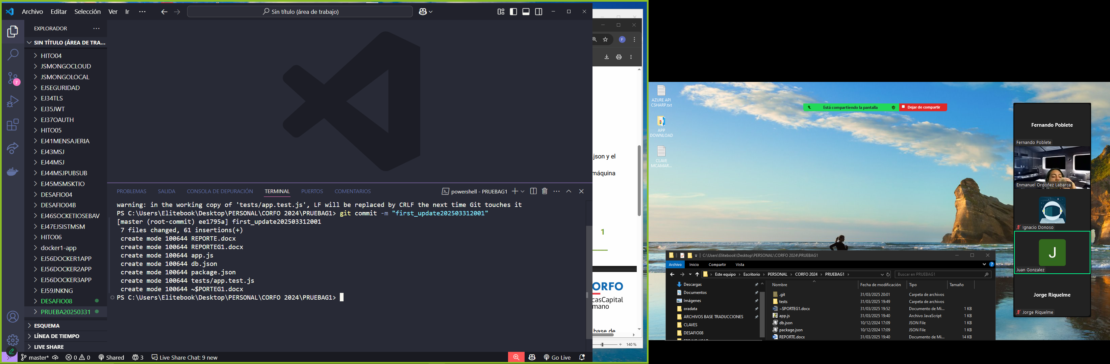

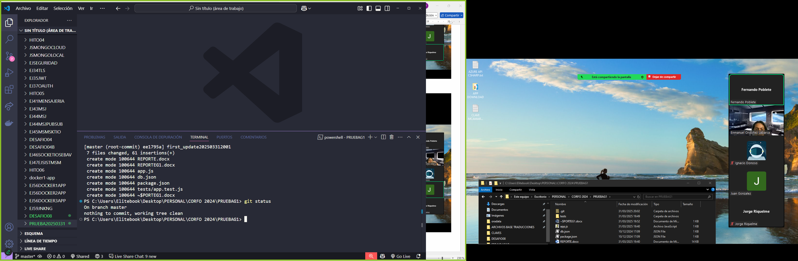

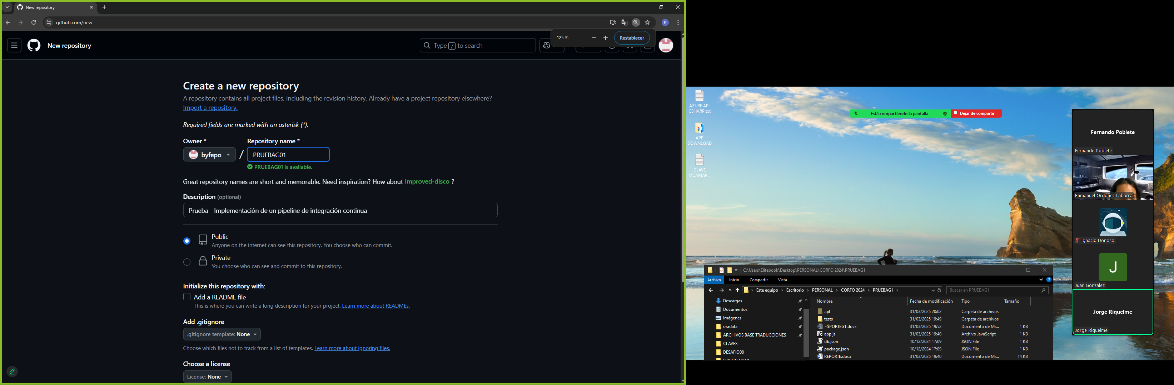

<https://github.com/byfepo/PRUEBAG01.git>

**…or create a new repository on the command line**

echo "# PRUEBAG01" >> README.md

git init

git add README.md

git commit -m "first commit"

git branch -M main

git remote add origin https://github.com/byfepo/PRUEBAG01.git

git push -u origin main

**…or push an existing repository from the command line**

git remote add origin https://github.com/byfepo/PRUEBAG01.git

git branch -M main

git push -u origin main

